PRESS RELEASE  MEDIADAYS 2026: RECONNECT  BRUSSELS 26 NOVEMBER · MARSEILLE 10 DECEMBER · PARIS 15 DECEMBER | 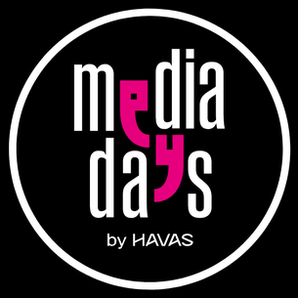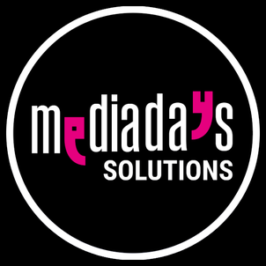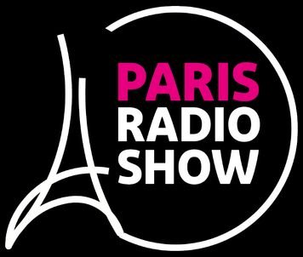
Information, registration and accreditation: mediadays.pro, mediadays.net and mediadays.solutions

MEDIADAYS 2026 SCALES UP AND MOVES INTO THE CARROUSEL DU LOUVRE ON 15 DECEMBER
After three years touring the French regions, MediaDays opens an XXL Paris edition on 15 December, preceded by two other events, including a first international one in Brussels.
Paris, 3 November 2026. Conceived and developed by Jean-Paul Mullie and Vincent Polenne at Havas Media Network, MediaDays has become, over three editions, the travelling event for the media, advertising and marketing industry. Three cities a year, one day per city, free of charge and open to the whole market: Lille, Lyon and Nantes in 2023, Lille, Marseille and Bordeaux in 2024, Lyon, Strasbourg and Lille in 2025. In 2026, MediaDays changes scale. It comes to Paris, to the Carrousel du Louvre, in an XXL format, and goes international for the first time with an event in Brussels.
The original bet was simple: the market’s needs are not only in Paris. For three years, MediaDays went to meet advertisers, agencies and sales houses where they work, in cities that host few events devoted to the media. Nine events, nine days, and one subject that never changed: the transformation of media and communication. “La transformation positive” (positive transformation) in 2023, “Transformation sous influence” (transformation under influence) in 2024, “Et demain la communication ?” (and what next for communication?) in 2025. In 2026, MediaDays answers its own question in a single word, “Reconnect”, and changes scale to live up to it.
“MediaDays is a new event format: it is THE meeting point for the whole market, media, agencies, advertisers and publishers. In a single day, visitors can get a complete picture of the media and communication ecosystem,” says Vincent Polenne, general coordinator of MediaDays.
The three events are not three copies of the same thing. Each one answers a question specific to its territory.
In Brussels, on 26 November at Mix Brussels, MediaDays crosses a border for the first time. The event addresses the country as a whole and is held in three languages: French, English and Dutch. 800 professionals are expected. It is a day focused on communication. The MediaDays Solutions programme takes place in the video podcast studio, around three subjects: programmatic advertising in Belgium, the place of traditional media and that of start-ups. Programmatic is a sensitive issue in a market divided by language, where local players negotiate with platforms designed for much larger markets.
In Marseille, on 10 December at the Palais du Pharo, MediaDays returns to a city it already visited in 2024. The event brings together more than 50 partners from across the South of France, and more than 1,000 professionals are expected. Discussions focus on the place of regional media and of start-ups, practical subjects that the major national events rarely tackle head-on.
In Paris, on 15 December at the Carrousel du Louvre, the main edition covers 6,600 m². It brings together six sectors and, across both halls, 150 partners, 50 sessions, 150 speakers and 20 start-up pitches. 3,000 to 5,000 visitors are expected. Admission is free for publishers, media agencies and brands.
What Paris adds to MediaDays
The Paris edition is the first to spread over two halls. The first, the communication, marketing, media and inspiration hall, in the Delorme and Gabriel rooms, remains the historic heart of MediaDays, with sales houses, publishers, retailers and creative agencies. The second, the Solutions hall, is a new space dedicated to solutions, in the Le Nôtre room. It brings together adtech, data, broadcasting, video, outdoor, audio, start-ups and the creator economy, and hosts the Paris Radio Show conference space, with its own stage and its own programme.
Between the two, the Foyer is the shared entrance that everyone walks through. It hosts research and measurement companies, in-car solutions, meaning the technologies built into vehicles, and the So Media video podcast studio, present on all three dates. The two halls are clearly separated, so that every visitor knows where to go, but both audiences move through the same building, on the same day, and cross paths from the entrance.
“The question is no longer which pipe carries the sound or the picture, but who pays for content, and how. That is the subject MediaDays Solutions puts on the table, and it cannot be settled among specialists of a single trade,” says Philippe Chapot, coordinator of MediaDays Solutions.
This coming together reflects a deeper shift. The question facing the media is no longer only about distribution, it is about the business model: who pays for content, through which channels, with which solution and which measurement. That question is worked out with sales houses, advertisers and data players, who are now in the same building. This is the meaning of the theme chosen for 2026, “Reconnect”: bringing back together trades that specialisation had driven apart.
THE THREE 2026 EVENTS
DATE AND CITY | VENUE AND HOURS | FORMAT
Thursday 26 November  Brussels | Mix Brussels  9 am to 6 pm | First international event, in three languages, French, English and Dutch. 800 professionals expected.
Thursday 10 December  Marseille | Palais du Pharo  9 am to 6 pm | The event of the South. More than 50 partners and more than 1,000 professionals expected.
Tuesday 15 December  Paris | Carrousel du Louvre  8:30 am to 6 pm | The XXL edition, two halls on 6,600 m². 3,000 to 5,000 visitors expected, free admission for publishers, media agencies and brands.

PRESS REGISTRATION
The accreditation form is built into the page: mediadays.pro/en/press, and in French mediadays.pro/fr/presse. Accreditation can be requested until 15 December 2026. Press releases can be read freely there; after registering, a personal access link opens the logos, visuals and press kit.
Attachments: infographic and venue photos available. Photo credit required with every publication: © Mix Brussels for Brussels, © Palais du Pharo for Marseille, © Olivier Brunet for Paris.
ABOUT THE ORGANISERS
MediaDays is organised by Havas Media Network. MediaDays Solutions is coordinated by Éditions HF, which hosts the Paris Radio Show conference space within it.
About Havas Media Network
Havas Media Network puts the power of human intelligence at the service of the most advanced technologies to support brand growth. Through our integrated operating model, Converged.AI, we help our clients become more relevant, agile and effective in a constantly changing environment.
Havas Media Network is part of the Havas group, one of the world’s leading integrated groups in content, media and communication, with nearly 23,000 people across media, creative, production and technology expertise. We design and deliver tailored, consistent and connected customer journeys, drawing on resolutely forward-looking expertise:
- Activation and content
- Commerce and performance
- Data and technology at the core
Our agencies bring together more than 10,000 media experts in more than 140 countries, supported by a network of 73 Havas Villages, where multidisciplinary talent works side by side every day to serve our clients’ business goals.
The brands that trust us include BBC, Canal+, Crédit Agricole, Decathlon, Dolce & Gabbana, EDF, Emirates, Fidelity Investments, Grupo Carso, Hyundai, Jacobs Douwe Egberts, Kia, Leroy Merlin, Lidl, LVMH, PNC Bank, Puma, Reckitt Benckiser, Red Bull, Sanofi, Shell, Telefónica, YUM Brands and many more.
PRESS CONTACTS
Dimitri Hommel  Head of press relations, Havas Media Network  dimitri.hommel@havas.com  Mobile: +33 6 98 20 77 12 | Philippe Chapot  MediaDays Solutions and Paris Radio Show  philippe@mediadays.solutions  Mobile and WhatsApp: +33 6 22 70 61 79
